**PROGRESS REPORT OF AUTONOMOUS COLLEGE**

**ACADEMIC YEAR: 2022 – 23 (1st July, 2022 – 30th June, 2023)**

**ARYA VIDYAPEETH COLLEGE(AUTONOMOUS)**

**ARYA NAGAR, GUWAHATI – 16**

**TABLE OF CONTENTS**

|  |  |  |
| --- | --- | --- |
| Sl No. | Title of Contents | Page No. |
| 1 | About the College | 1 |
| 2 | Academic Activities | 2 |
| 3 | Research Activities | 5 |
| 4 | Administrative Activities | 6 |
| 5 | Extension Activities | 15 |
| 6 | Financial Report | 18 |

**About the College:**

Arya Vidyapeeth College (Autonomous) was established on 29th July, 1958. It is one of the pioneer higher education institution of Assam becoming a beacon of learning and a symbol of aspirations for the common people of Assam. Arya Vidyapeeth College has been identified by the University Grants Commission (UGC) as an institution with potential for excellence. The “***College with Potential for Excellence”* (CPE)** distinction with its accompanying grant has helped the institution to scale greater heights of excellence. It may be mentioned that six departments of the college has been selected by the Department of Biotechnology (DBT), Ministry of Science and Technology under “Star College Scheme”.

The college has been granted autonomous status by UGC on 26th May, 2022 for ten years from the session 2022 – 23 (Letter No.F.22-1/2022(AC)) for all programs run under auspices of UGC. Subsequent to the approval by UGC, Gauhati University declared the autonomous status of the college vide letter no: GU/AFF/2022/5066-69, dated: 23rd June, 2022. This report has documented the progress of the college after being granted autonomy during the academic year 2022 – 23.

**THE ARYAN VISION:**

The College was established by the founder principal late Pandit Giridhar Sarma with the vision to cater to the need for higher education and to tap the intellectual potential of the youth of Assam in particular and the entire North East India in general. The College aspires to uphold the national policies on higher education which is to mould and prepare the young minds to meet contemporary challenges with special focus on the underprivileged students. Guided by the principles of inclusiveness, integrity, innovation, creativity and quality, the College has a vision to create an environment that is responsive to the needs of students and society at large.

**THE ARYAN MISSION:**

The College since its inception has committed itself to the realization of the ideals reflected in the vision of the College. The missions of the College are:

• To enrich and empower the young generation through quality education.

• To achieve academic brilliance and prepare students to play a positive and meaningful role in nation building.

• To develop a vibrant academic ambience for research and higher studies.

• To organize vibrant development programmes and services to help students identify educational and career goals and set realistic career paths.

• To make higher education accessible to the underprivileged section of the society.

• To introduce innovative techniques to make the teaching-learning process more effective.

• To prepare individuals for productive contribution to society.

• To develop the potential of the students in co­ curricular and extracurricular fields through participation in literary, cultural, sports, and extension activities.

• To sensitise students towards social concerns like gender and environmental issues, human rights, ethical and patriotic values.

**THE ARYAN GOALS AND OBJECTIVES:**

For the fruitful realization of our Vision and Mission, certain goals and objectives have been chalked out.

• Encourage students to identify their latent talent and potential;

• Produce high stratum outputs from the low inputs;

• Cater to the needs of academically disadvantaged students;

• Equip the students with some value added courses;

• Promote co-curricular activities amongst the students to develop healthy habits;

• Mould students into ideal citizens and thereby fulfill social obligations; and

• Promote and develop research culture among the faculty members.

**I. Academic activities:**

In the first academic year (2022 – 23) the college had adopted the syllabus of Gauhati University for both Undergraduate and Post Graduate Courses after obtaining due permission from the authorities of Gauhati University.

The Govt. of Assam announced that NEP, 2020 shall be implemented from the academic session 2023 – 24. Hence the college initiated the process of framing syllabus as per NEP, 2020 as follows:

* The college has offered four-year undergraduate course curriculum with single major under NEP, 2020 from the academic session 2023 - 24 . The total credit a student has to acquire to get a degree (Honours/Honours with research) under FYUGP is 160 and 120 credits to get a degree after three years. The credits are equally distributed with 20 credits in each semester. The college has followed the UGC regulations regarding “Credit distribution matrix under FYUGP (single major)”. This distribution matrix has been approved by the Academic Council vide resolution no: AC – 01/2023/03(a) dated: 31 – 03 – 2023.

The College has offered barrier less subject pool. The subject pools, course code and subject code has been placed in the Academic Council which has been approved vide resolution no: AC – 01/2023/03(b) dated: 31 – 03 – 2023.

* The syllabus of each course offered by the college for each level has been prepared in such a manner so that the learners fulfil the learning requirements or outcomes as given in NHEQF
* All the departments of the college have organized BoS for approval of the syllabus of various course components (Core, Minor, AEC, SEC, VAC/FC and MDC/IDC) for first two semester.
* The Sanskrit Department of the college has developed a course “Ancient Indian Studies” under Value Added Course Component.
* If a student desires to change his core (major) subject, he may be allowed to do so in 3rd semester only subject to availability of the seats and condition lay down by the concerned department.
* The change of minor subject is allowed in 3rd, 5th and 7th semester.
* A Department of Skill Development and Entrepreneurship has already been established with the present faculty members. The department co-ordinates with external agencies/institute/industry for resource sharing to impart skill based/vocational courses. It has already conducted 30 + hours of skill development courses on Financial Literacy, Personality Development & Spoken English, Basics of Remote Sensing & GIS and their applications and Plant Tissue Culture.

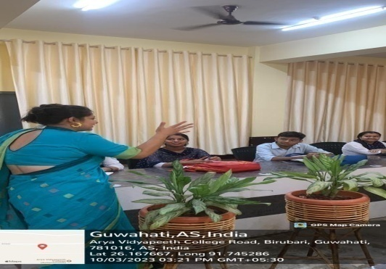 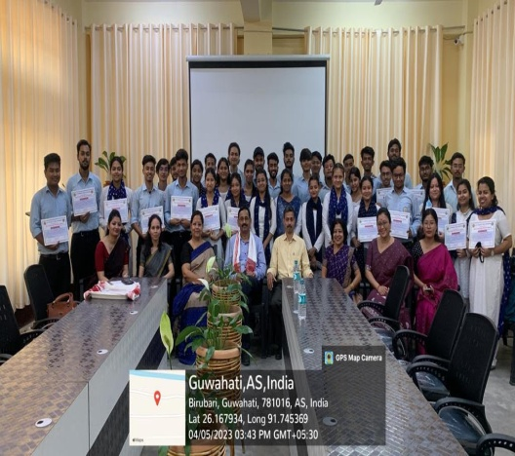

**SKILL DEVELOPMENT COURSES**

* The college has already registered at ABC through NAD. The ID of the college at NAD is NAD044818. The Digital Marksheet template (DGMST) no: 2 has been chosen for the college.
* Both the Governing Body and Academic Council of the college has approved the establishment of the Departments of Data Science, Sociology, Psychology, Computer Science and Disability Studies. The Department of Disability studies has already conducted one certificate course.
* The college has already started the process to open P.G and Ph.D courses in different departments in a phased manner.
* The college has also adopted “Multiple entry and Multiple exit” as per NEP, 2020 guidelines.
* The number of working days(90 days) per semester adopted by the college is as per “National Credit Framework” The Academic Calendar of the college has also been framed by taking into consideration the above mentioned number of working days.
* The college has framed its own assessment and evaluation structure. The ratio of formative and summative assessment adopted at present is 30:70 which shall be increased to 40:60.
* From 2nd Semester onwards, the college shall assess Course Learning Outcome Attainment Levels. For this purpose, the requisite guideline has been framed which shall be placed in the next Academic Council meeting.

**II. Research Actitivities:**

With a view to facilitate more opportunities in research, the college boasts of an active Research and Developmental Cell, formed under the guidelines of UGC that offers support and guidance to faculty members. To promote excellence in research in higher education, each year, a few faculty members are supported to meet their requirements for individual research in specialized areas through the Institutional Research Grant. The award of research projects were done on 28 – 06 – 2023 this year. A total of eight(8) faculty members both from Arts and Science stream were awarded the grant

The Research and Development cell also aims to motivate students and instil in them an interest in the field of research. Research is also promoted at the department level through curriculum based research projects with fellow students and faculty members as mentors and supervisors. The College also has a North-East study centre which promotes research among students.

There are five departments having research projects funded by Government and Non-Government agencies during the year. This academic year 7 students registered under Ph.D programme in different departments. 36 numbers of research papers were published by the faculty members in CARE journals notified by UGC in the academic year 2022 – 23. Number of books and chapters in edited volumes / books published per teacher during the year is 24. Total number of citations in Scopus this year is 1369 and h-index is 127

|  |  |
| --- | --- |
| Activities of faculty members | Total number |
| Number of conferences attended/paper presented | 75 |
| Number of research publications in UGC care listed journals/peer reviewed journals/ refereed journals | 70 |
| Number of Books/Book Chapter published | 48 |
| Number of Seminars attended as Chairperson/ Resource Person | 21 |
| Number of Faculty development programmes attended | 163 |
| Number of Workshops attended | 112 |
| Number of lectures delivered as invited speaker | 33 |

**III. Administrative structure with activities**

The college has constituted the statutory bodies as per the UGC guidelines for Autonomous College 2023.

**Governing Body:** The Governing Body constituted as per UGC guidelines for Autonomous College, 2023, is given below. Before the formation of this body, the Governing body as per affiliated college structure was functioning.

|  |  |  |
| --- | --- | --- |
| **Sl No.** | **Name** | **Designation** |
| 1. | Prof. Jogen Chandra Kalita, HoD, Dept. of Zoology, GU | Chairman |
| 2. | Dr. Sanjib Raj, Director, Assam Institute of Management, Boragaon | Member, State Govt. Nominee |
| 3. | Prof. Ashok Kr. Borah, Dept. of Geography, GU | Member, University Nominee |
| 4. | Shri Shyam Kanu Mahanta, Entrepreneur | Member, Nominated by State Govt. |
| 5. | Sri Dipankar Bora, State Innovation and Transformation Ayog, Economist | Member, Nominated by State Govt. |
| 6. | Mrs. Anita Talukdar, Vice Principal | Teacher Member |
| 7. | Dr. Moushumi Dutta Pathak, Associate Professor, Dept of History | Teacher Member |
| 8. | Prof. Hemanta Kumar Sarmah, Dept. of Mathematics, GU | Educationist |
| 9. | Dr. Ranjan Das, Controller of Examinations | Administrative Officer |
| 10. | Dr. Dalimi Devi, Librarian | Member |
| 11. | Dr. Pradip Kr. Bhattacharyya, Principal | Member Secretary |

During the period, five (05) nos of Governing Body meetings were held. A brief account of the proceedings of the Governing Body meetings is given below:

The first meeting of the Governing Body under autonomous status was held on 02 – 07 – 22.

* In this meeting discussion was done on the various aspects regarding implementation of autonomous status to the college like formation of the various statutory bodies, drafting of rules and regulations for autonomous colleges, courses and syllabus for the first academic session (2022-23) under autonomous status etc.
* Discussion on construction of 3rd Floor of Block C was also made.
* The meeting also approved the CAS promotion of faculty members of various departments.
* The meeting also formed a committee to verify the application forms for appointment of Boys’ and Girls’ Hostel Superintendent.

The second meeting of the Governing Body was held on 24 – 08 – 22

* This meeting gave the permission for advertisement of Grade III and Grade IV posts.
* The meeting also discussed regarding the conduct of examinations under autonomous status.
* The meeting also constituted a committee to frame the Ph.D guidelines of the college and also approved the opening of PG courses in a phased manner.
* The meeting also approved the management committee of KKHSOU
* The meeting also discussed the proposal to construct the Block D

The third meeting of the Governing Body was held on 10 – 12 – 22

* The meeting approved the bill payment against construction of Block C
* The meeting approved the appointment of Dr. Mousumi Bora and Dr. Rahul. S. Mazumdar as Dean (Academics) of the college and constituted a committee to frame the duties and responsibilities of the Dean (Academics). The approval to appoint Prof. Parag Phukan as the academic advisor of the college was also given.
* The meeting also discussed the implementation of NEP, 2020 from the session 2023 – 24.
* The meeting also approved the formation of new IQAC with Dr. Anupama Devi as the co-ordinator.
* The meeting also approved the opening of Departments of DataScience and Machine Learning, Sociology, Psychology, Computer Science and Disability Studies. The meeting also approved the opening of honours course in the Department of Hindi in self sustaining course with due approval from the Govt. of Assam.
* The meeting also approved the budget for construction of the boundary wall of Boys’ Hostel and construction of septic tank in Girls’ Hostel.

The fourth meeting of the Governing Body was held on 25 – 04 – 23.

* The meeting approved the e-tender for construction of Block D
* The meeting also approved the appointment of Grade III and Grade IV employees against sanctioned posts.
* The meeting also discussed the formation of a committee for proper utilization of NEC grant.
* The meeting also approved the college budget for the session 2023 – 24.

The fifth meeting of the Governing Body was held on 10 – 06 – 23.

* The GB resolved to allow the Principal to issue work order to the lowest bidder for the construction of ground floor and first floor of Block D.
* The meeting approved the appointment of Dr. Amal Kr. Agarwal , HoD, Department of Statistics as Dean (Faculty of Science).
* The meeting also constituted the inspection team for opening of post-graduate courses.

Besides these, regular matters like additional budgets, appointment of contractual teaching and non-teaching staff, approval of earned leave and CCL of the staff of the college are also placed before the Governing Body for approval.

**Academic Council:**

|  |  |
| --- | --- |
| Chairman | Dr.Pradip Kr. Bhattacharyya, Principal, Arya Vidyapeeth College(Autonomous) |
| Members | All HoDs |
| Nominees from Gauhati University (Members) | Dr. Partha Pratim Baruah, Dept. of Botany, GU |
| Dr. Kishore Das, Dept. of Statistics, GU |
| Dr. Shakuntala Bora, Dept. of Philosophy, GU |
| Nominees made by GB of the College (Members) | Dr. Jatin Sarmah, Dept. of Biotechnology, Bodoland University |
| Dr .Dipak Sarma, Dept. of Mathematics, Cotton University |
| Dr. Utpal Sarma, Dept. of Instrumentation and USIC, GU |
| Dr.Subhrajeet Konwar, Dept. of Political Science, GU |
| Teacher representative of the college nominated by the Principal (Members) | Mrs. Anita Talukdar, Vice Principal |
| Dr. Amal Kr. Agarwal, Dean (Faculty of Science) |
| Dr. Mousumi Borah, Dean (Academics) |
| Dr. Rahul. S. Mazumdar, Dean (Academics) |
| Dr.Ranjan Das, Controller of Examinations |
| Dr. Anupama Devi, IQAC Coordinator |
| Dr.Sumita Bhattacharjee, Dean (Faculty of Arts) |
| Member Secretary | Dr.Anupama Devi |

During the period, one (01) no of Academic Council meeting was held. Some important resolutions are:

1. The council resolved to approve the names of the members for the Board of Studies of different departments of Arya Vidyapeeth College (Autonomous).
2. The council resolved to implement FYUGP and various features under NEP, 2020 from Academic Session 2023 – 24.
3. The council approved the Credit distribution matrix under FYUGP (single major) with the suggestion that the course code needs to reflect course level.

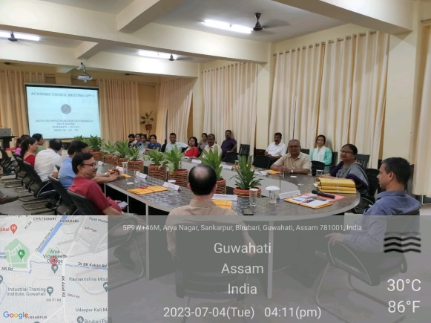  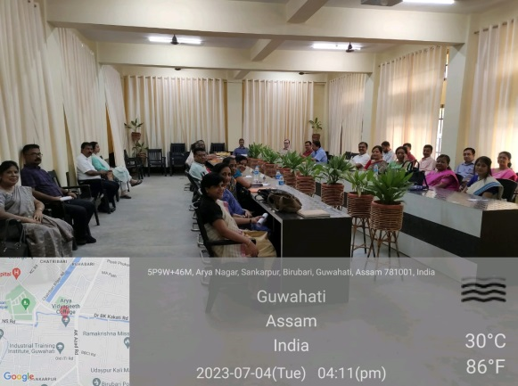

**ACADEMIC COUNCIL MEETINGS**

**Finance Committee:**

|  |  |
| --- | --- |
| Dr. Pradip Kr. Bhattacharyya, Principal, Arya Vidyapeeth College(Autonomous) | Chairman |
| Dr. Biren Das | Member |
| Mrs. Anita Talukdar, Vice Principal | Member |
| Mr. Aboni Das (Accountant) | Member Secretary |

During this period three (03) meetings of the Finance Committee were held. Some important resolutions are :

1. The finance committee discussed the matter of revised fee structure and remuneration under different heads of examinations and the committee resolved that the rates as per format with comparison to GU approved rates.
2. The committee discussed the college general budget of expenditure and recipient as per needs.
3. The committee recommended the general budget to the G.B of the college for final approval.

**Board of Studies:**

The college has constituted twenty one (21) Board of Studies including an interdisciplinary Board of Studies in faculty of Arts, Science and Commerce as per the structure given in UGC guidelines for Autonomous Colleges, 2023. The Board of studies belonging to faculty of Arts, Science and Commerce approved the syllabi of respective arts, science and commerce discipline.

The interdisciplinary Board of Studies was constituted to approve the syllabi of interdisciplinary subjects like Environmental Studies, Data Science and Disability studies.

**Examination Committee:**

The college has an apex body, which is the Examination Committee to decide over certain examination related matters which are brought into notice by the Office of the Controller of Examinations. The members of the examination committee are:

|  |  |
| --- | --- |
| Principal | Dr. Pradip kr. Bhattacharya |
| Controller of Examinations | Dr. Ranjan Das |
| Deputy Controller of Examinations (Academics) | Dr. Manab Deka |
| Deputy Controller of Examinations (Technical) | Dr. Bhupali Sharma |
| Dean (Academics) | Dr. Mousumi Bora |
| Dean(Academics) | Dr. Rahul.S. Mazumdar |
| Dean (Faculty of Science) | Dr. Amal Kr. Agarwal |
| Dean (Faculty of Arts) | Dr. Sumita Bhattacharjee |
| Head of the Department (Commerce) | Dr. Kallol Bhattacharya |
| IQAC, Co-ordinator | Dr. Anupama Devi |

**Examination Cell:**

The Examination Cell of the college is formed for the conduction of examination in the college The cell is responsible for conduction of examinations both internal and external, evaluation, publication and display of results. It maintains all the records of the student evaluations and examinations for all UGC approved courses offered by the college which falls under the purview of Autonomy. The Office of the Controller of Examination conducted examination for both odd and even semesters for the period 1st July, 2022 to 30th June, 2023. It may be mentioned that printing of all question papers, answer sheets etc are done in – house by the Office of the Controller of Examination

The structure of the examination cell of the college is:

|  |  |
| --- | --- |
| Chief Controller of Examinations | Dr. Pradip kr. Bhattacharya, Principal |
| Controller of Examinations | Dr. Ranjan Das |
| Deputy Controller of Examinations (Academics) | Dr. Manab Deka |
| Deputy Controller of Examinations (Technical) | Dr. Bhupali Sharma |
| Teacher Member | Mr. Udipta Talukdar |
| Teacher Member | Ms. Jintimoni Bora |

* The results of end semester examinations conducted under autonomous status was declared within 45 days from the last day of the examination

**Committees and Cells:**

For the smooth functioning of the different activities,both academic and extra-curricular, several committees and cells like Academic and NEP cell, disciplinary committee, Women Cell, Internal Complain Committee, Grievance Redressal Cell, Career Counselling cell, Committee for Academic and Personal Counselling, Yoga Cell, Science Club, Eco Club etc have been formed.

**Teaching Staff:**

|  |  |  |  |  |  |  |  |  |
| --- | --- | --- | --- | --- | --- | --- | --- | --- |
| **Number of** | | Total | **Number of Teachers with** | | | | | |
| Assistant Professors | Associate Professors | Ph.D. | MPhil | NET | SLET | D.Lit | D.Sc |
| 76 | 29 | 105 | 78 | 15 | 35 | 22 | 0 | 0 |

**IQAC:**

The IQAC was reconstituted on 1st January, 2023 with the following members as per AQAR guidelines for autonomous colleges.

Dr. Pradip Kr. Bhattacharyya, Chairperson, Principal

Dr. Anupama Devi, Co-Ordinator

Teacher Members

* Dr. Biren Das, Associate Professor
* Dr. Manab Deka, Associate Professor
* Dr. Jyotirupa Sarma, Assistant Professor
* Dr. Dulumoni Sarma, Assistant Professor (S.G.)
* Dr. Rongina Narzary, Assistant Professor
* Dr. Purnima Saha, Assistant Professor
* Dr. Bhabesh Das, Assistant Professor
* Dr. Pearl S Gogoi, Assistant Professor
* Dr. Rajarshi Bayan, Assistant Professor

Member from Management

Prof. Ashok Kr. Borah, Department of Geography, Gauhati University

Member (Senior Administrative Officer)

Mr. Abani Das

Member from Employer

Dr. Tapan Dutta, Principal, J.N. College, Boko

Industrialist

Mr. Shyam Kanu Mahanta, Renowned Entrepreneur and Columnist

Member from Alumni

Prof. Hemanta Kr. Sarmah, Dept. of Mathematics, Gauhati University

Member from Local Society

Mr. Pradyut Kr. Choudhury, Retd. Chief Engineer, PWD

Member from Stake Holders

Dr. Girish C. Sarma, Dept. of Statistics, A.V. College (Retd.)

Student Member

General Secretary, AVCSU

**Notable Activities of IQAC:**

* The IQAC in association with “ NEP implementation cell” has framed the “Credit distribution matrix”, course code etc of FYUGP.
* The IQAC has prepared and submitted the “Institutional Development Plan” of the college
* As a part of consultancy services initiated by the IQAC two MoUs were signed with J.N. College, Boko and Jagiroad College. The consultancy services are given in:
* Preparation of IDP
* Preparation of SSR
* Preparation for the proposal for applying autonomous status to UGC.
* A three-day “Capacity building workshop on designing Question Paper” was organized by the Office of the Controller of Examinations, Arya Vidyapeeth College (Autonomous) in collaboration with Internal Quality Assessment Cell (IQAC) of the College. The workshop was held at the College premises from 15th to 17th June, 2023 with technical support from Azim Premji University, Bengaluru.
* The IQAC had organized various programmes on the themes suggested by Ministry of Culture, Govt. of Assam as a part of “ Azadi Ka Amrit Mahotsav” Celebration.
* The IQAC also conducts several awareness programmes on various issues like cyber security etc. regularly.
* Besides these activities, the IQAC is involved in performing its regular activities like collecting feedback from its stakeholders, conducting student satisfactory survey, collecting the self-appraisal report and teaching plans from the faculty members, monitoring and updating the college website etc.
* The minutes and resolutions of IQAC meetings together with action taken report is uploaded in the college website at the end of every academic session.
* The report of feedbacks taken from various stakeholders together with action taken report is also uploaded in the college website at the end of every academic session.

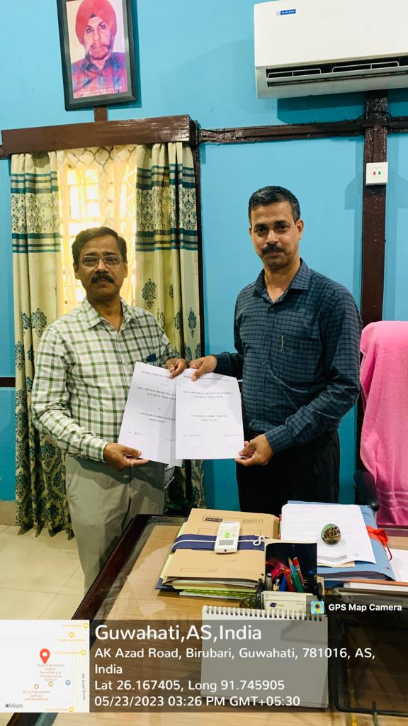 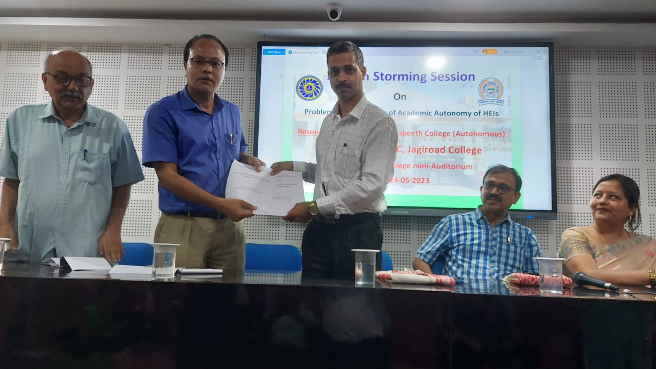

MoU with Jagiroad College

MoU with J.N. College, Boko

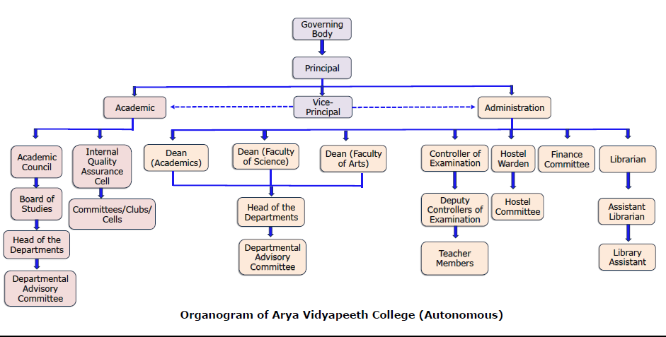

**IV. Extension activities**:

Arya Vidyapeeth College prioritizes holistic education, combining academic excellence with extensive engagement in socio-cultural, economic, and environmental contexts through various dedicated cells. Notable outreach and extension activities are:

* The College has adopted Garbhanga village in the periphery of Guwahati city. The College has adopted the only lower primary school of the village and has taken certain positive steps to help and support it. The teachers of the College are actively engaged in empowering the students of the said village in terms of education and social responsibility. The MoU was renewed this year.
* Pamohi has been adopted by the NSS unit of the College. The NSS unit of the College organizes various camps in the village on regular basis.

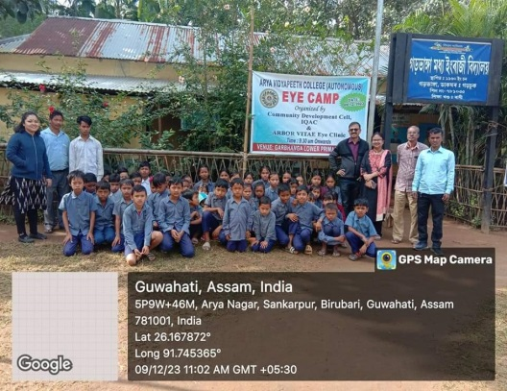 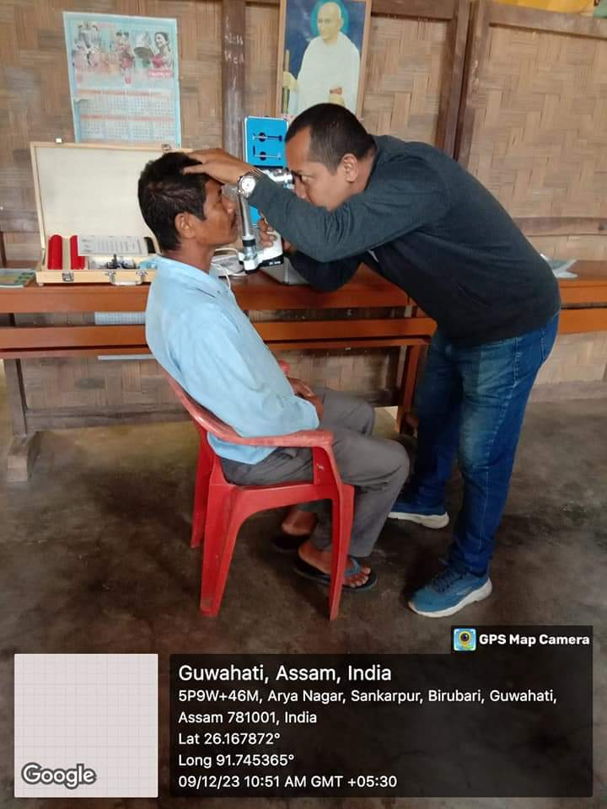

**EYE CAMP ORGANIZED AT GARBHANGA ON 9TH DECEMBER, 2023**

* Under the guidance of IQAC, NSS unit of the college has taken up community service programme in “New Harijan Colony” Fatasil Ambari. These programmes shall be carried out by NSS in association with various departments of the college throughout the year as a part of extension activity of the departments. The first programme was conducted on 30th March, 2023 in association with Dept. of Economics.

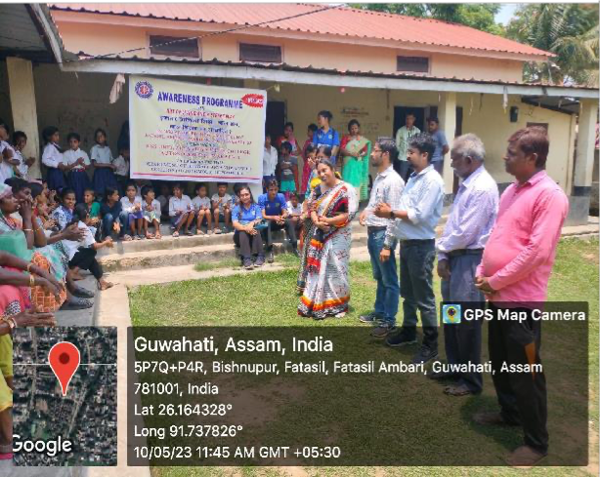 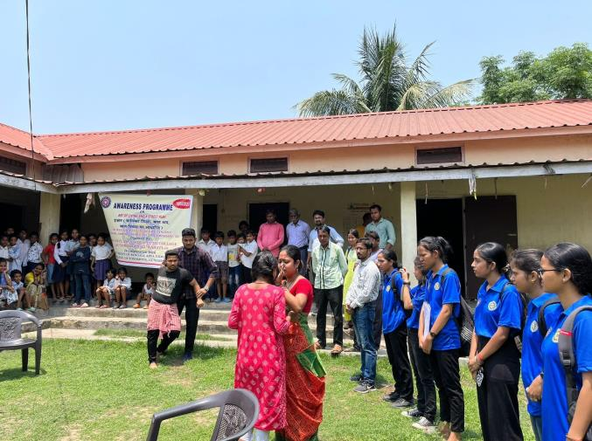

**COMMUNITY SERVICE PROGRAMME AT “NEW HARIJAN COLONY”**

* The IQAC has also initiated an extension activity for the faculty members. The students of “Child Friendly, Guwahati” (a project under Snehalaya) are taught by the faculty members of the college. The subjects discussed generally are English, Hindi, Mathematics , EVS and Extra Curricular activities.
* Different departments of the college have adopted many nearby schools as a part of their responsibility towards the society. The schools are provided with the available resources like teaching faculty, books, laboratories etc. The students of the schools are highly benefitted by the computer laboratory of the college which boasts of about nearly 80 computers.
* Health camp and Blood Donation Camp are organized regularly
* Plantation Drive
* Anti-plastic pollution program
* Fruit sapling drive on World Environment Day.
* NSS unit of the college carried out an awareness programme on corporal punishment and cyber bullying on the occasion of National Service Scheme Day on 24th September, 2022. It also carried out cancer Awareness Campaign in nearby areas of the college on 4th February, 2023.

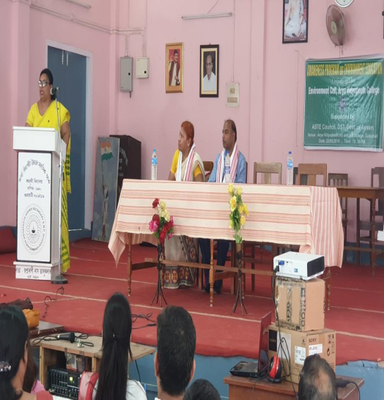 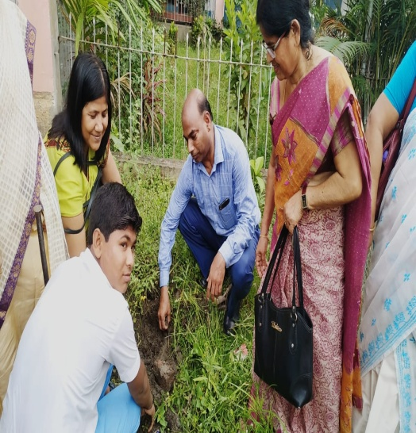

**AWARENESS PROGRAMME ORGANIZED BY CLUBS AND CELLS**

* 60 Assam Girls' BN NCC and 1 Assam BN NCC of the college also carries out various extension activities and awareness programmes on AIDS (01 – 12 – 2022), pollution (02 – 12 – 2022), road safety (11 – 01 – 2023 ), Yoga (21 – 06 – 2023 )etc. It has also conducted a self-defense class on 06 – 01 – 2023.
* Most of the departments have adopted nearby schools as a part of extension activity of the faculty members.

**V. Financial report:**

|  |  |  |  |  |  |  |
| --- | --- | --- | --- | --- | --- | --- |
| Item | Unutilized Grant available from Previous year  (2021 – 22) | Resources generated through fees and other sources  (2022 - 23) | Grant received from UGC and other funding agencies during the year  (2022 - 23) | Expenditure during the year  (2022 - 23) | Unspent balance  (2022 -23) | Remarks |
| 1 | Rs. 527810.10 (RUSA) | Rs.38120823.00 | Rs. 6984161.00  (RUSA) | Rs.7106204.00 (RUSA)  Rs.27423033.00  (Fees and other Sources) | Rs. 405767.10  (RUSA)  Rs.10697790.00  (Fees and other Sources) |  |

Principal,

Arya Vidyapeeth College (Autonomous)

Comments by the members of the peer team:

Signatures:

1.

2.

3.

4.